SEPTEMBER 2018 | WWW.MAKAUFMAN.COM

 | The Kaufman Law Review

  SERIOUS
  PERSONAL
  INJURY, MEDICAL
  MALPRACTICE
  &
  WRONGFUL
  DEATH
  TRIAL
  ATTORNEYS
  WORKPLACE SCAFFOLD COLLAPSE
  $1,300,000 JURY VERDICT
  We represent a young man who was employed as a carpenter to complete a renovation for a local newspaper company. While working on the scaffold, 40 feet above the lobby floor, the scaffold broke causing our client to fall from the scaffold onto the marble floor below. The fall shattered both of our client's legs necessitating multiple surgeries. Due to the severity of the injuries, our client could not return to work.
  This case went to trial and the jury awarded our client reimbursement for his medical expense, his lost earnings and the pain and suffering that he will have for the rest of his life.
  Workplace accidents are common and we recommend that you consult with us immediately after a work related accident so that we can get critical evidence to support the potential claim. If you wait, critical evidence may not be obtainable.

MARC A. KAUFMAN & ASSOCIATES
WWW.MAKAUFMAN.COM
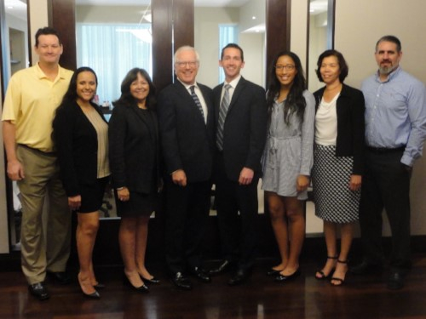 | BOCA RATON  2255 Glades Rd, Ste 324A  Boca Raton, FL 33431  P: (561) 997-5600  F: (561) 991-5660  FORT LAUDERDALE  350 E. Las Olas Blvd, Ste 970  Fort Lauderdale, FL 33301  P: (954) 838-8880  F: (954) 838-1388  MIAMI  2665 S. Bayshore Dr, Ste 603  Coconut Grove, FL 33133  P: (305) 688-8100  F: (305) 688-8688
unsubscribe from this list | update subscription preferences

